11th INTERNATIONAL BROWN COAL MINING CONGRESS IN BEŁCHATÓW

“BROWN COAL – ALTERNATIVE DIRECTIONS OF APPLICATION”

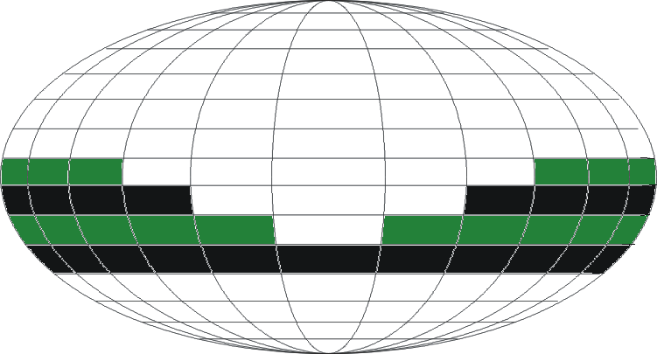

Communication no. 1

Organisers:

PGE Górnictwo i Energetyka Konwencjonalna S.A.
PGE GiEK S.A. Bełchatów Lignite Mine Division
Stowarzyszenie Inżynierów i Techników Górnictwa, Bełchatów Branch Office

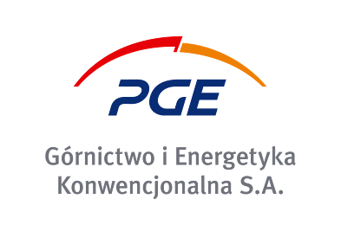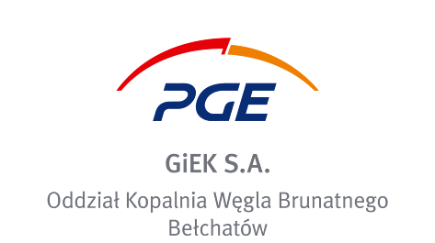
B e ł c h a t ó w

20 – 22 April 2020
Bełchatów – Sport Hotel

Ladies and gentlemen,
We are honoured to invite you to take part in the International Brown Coal Mining Congress, which will be held in Bełchatów - Poland’s largest mining and power engineering centre, between 20th and 22nd of April 2020, with main theme of:
“Brown Coal – Alternative Directions of Application”

During the Congress, Belchatow will be not only Poland’s, but also the world’s capital of lignite mining. It will become the place of integration and networking of people from the mining and power industry communities.
Scientists, experts and people working in the mining and power industries will tackle issues of importance for the economy, related to the future of the cheapest source of energy that is brown coal – a crucial stabilising factor of Poland’s energy security. We intend to focus on directions and technologies based on lignite, such as: production of semi-coke, low-temperature tar, industrial gases, liquid fuels or montan wax.

We intend to include the following issues in the subject scope of the Congress:

- The role of lignite in European countries and worldwide.
- Challenges facing the lignite industry in the context of the decarbonisation of the power industry.
- New lignite-based areas and technologies.
- Lignite as an alternative for other energy media.
- Gasification of coal.
- Changes in global lignite production and utilization trends.
- Poland’s energy mix until the year 2050.
- Lignite resources as a guarantee of energy security.
- The role of lignite in balancing and stabilising energy systems.
- Open-cast lignite mining – a time-intensive investments in new deposits and mining fields.
- Coal technologies with prospects.
- Lignite as substrate, fertiliser and raw material
- Energy production in coal-fired powerplants ensuring security of energy supply without geopolitical risk.
- Poland as a country endowed with brown coal deposits, using its resources prudently.
- Lignite mining quantities and their future outlooks.
- Environmental impact of opencast mines.
- European climate policy and the striving towards carbon emission reduction.
- Modern carbon capture and storage (CCS) technologies.
- Reclamation and revitalisation of mining areas.
- Continuous efficiency improvements of lignite-fired powerplants as a condition for maintaining their competitiveness among energy producers in Poland and worldwide.

SCIENTIFIC PAPERS
Papers with abstracts in Polish and English shall be accepted until 20 February 2020. The organisers reserve the right to perform a preliminary screening of the submitted papers. The approved papers will be published in the Congress materials on condition that the author enrols for participation in the Congress and pays the participation fee.

SCIENTIFIC COMMITTEE OF THE CONGRESS
Chairman:
prof. dr hab. inż. Tadeusz Słomka – Rector of the AGH University of Science and Technology in Kraków
Deputy Chairman:
prof. dr hab. inż. Zbigniew Kasztelewicz – Vice president for Mining of PGE GiEK S.A.
Members:
prof. dr hab. inż. Cezary Madryas – Rector of the Wroclaw Technical University
prof. dr hab. inż. Antoni Tajduś – AGH University of Science and Technology in Kraków,
Geomechanics, Civil Engineering and Geotechnology Department
prof. dr hab. inż. Marek Cała – Dean of the Mining and Geoengineering Department of AGH Kraków
prof. dr hab. inż. Piotr Czaja – Mining and Geoengineering Department of AGH Kraków
prof. dr hab. inż. Wiesław Kozioł – Institute of Mechanised Construction and Rock Mining - Warsaw,
AGH Kraków
prof. dr hab. inż. Monika Hardygóra ‒ Mining and Geoengineering Department of the Wroclaw University of Technology
prof. dr hab. inż. Dionizy Dudek – Machinery Design and Operation Institute of the Wroclaw University
of Technology
Senior Professor Maciej Pawlik – Electrical Power Engineering Institute, Powerplants Unit of the Lodz
University of Technology
dr hab. inż. Jacek Szczepiński – Director of Poltegor – Instytut. Open Cast Mining Institute.
dr inż. Miranda Ptak – Director of the Mining Management Department, PGE Górnictwo
i Energetyka Konwencjonalna S.A.

COMPANY PRESENTATION AND PUBLICITY
The organisers offer the following forms of presentation and publicity for your company during the Congress:
• company display (presentation of products, advertising materials, mock-ups etc.);
• presentation of your company at special promotional sessions during the conference;
• a promotional paper and colour advertisement included in conference materials.
• sponsoring: Gold, Silver, Bronze.
Detailed principles for collaboration will be established individually and stipulated in a contract.

CONGRESS FEES
The congress fee should be transferred to the organisers’ account by 31 March 2020 or as specified in terms of contract (for exhibitors).
The cost of participation in the Congress includes: congress materials, food, participation in two social meetings (feast, banquet) and amounts to PLN 2000 + VAT or EUR 600 (for foreign participants). Congress participants will be accommodated in single or double hotel rooms.
The hotel rooms shall be booked and paid for by the participants themselves. Details of the available hotel accommodation can be found on the REGISTRATION CARD.
Note: Cost of participation in the feast or in the banquet is PLN 600 per person (not applicable to Congress participants).
Bank account for payments:
Stowarzyszenie Inżynierów i Techników Górnictwa, Bełchatów Branch Office
ul. Kolejowa 41, 97-400 Bełchatów; NIP: 769-20-07-765; transfer note: KONGRES
PKO BP S.A., I O/Bełchatów; account no. for Polish participants:
68 1440 1257 0000 0000 0225 7963;
PKO BP S.A., I O/Bełchatów; account no. for foreign participants:
PL 68 1440 1257 0000 0000 0225 7963; SWIFT Code (BIC) BPKOPLPW;
After the payment is made, please send us a confirmation of your bank transfer to have the invoice issued and your name placed on the participants list promptly. For exhibitions, advertising, or sponsoring, we will send you the relevant contract for you to sign, after the registration card is received.

IMPORTANT DATES
Completed registration cards shall be submitted by 31 March 2020 to the e-mail address: waclawa.parolczyk@gkpge.pl, fax.+48 44 737 44 56, or by mail:

Correspondence address: Wacława Parolczyk; PGE GiEK S.A. Oddział Kopalnia Węgla Brunatnego Bełchatów Rogowiec,
ul. Św. Barbary 3; 97-400 Bełchatów, skr. poczt. 100; note on envelope: „KONGRES”.

CONTACT INFORMATION
 | Name | Tel. | Mobile | FAX | e-mail
Congress  Polish  Congress  English | Wacława Parolczyk | (+48) 44 737 4455 |  | (+48) 44 737 4456 | waclawa.parolczyk@gkpge.pl
 | Anna Kowalska |  | (48)  601 696 070 |  | anna.kowalska@gkpge.pl
Exhibition  Sponsoring  Advertising | Tomasz Szczepaniak | (+48) 44 737 4493 | 723 696 256 |  | tomasz.szczepaniak@gkpge.pl
 | Dariusz Kowalczyk | 48) 44 737 1555 | 723 696 144 |  | dariusz.kowalczyk@gkpge.pl
 | Michał Wojewoda | (48) 44 737 4495 | 723 696 258 | (48) 44 7374757 | michal.wojewoda@gkpge.pl
 | Grzegorz Organiściak | (+48) 44 737 1554 | 601 252 931 |  | grzegorz.organisciak@gkpge.pl
Other organisational information will provided in the next communication.

CONGRESS WEBSITE
www.kwbbelchatow.pgegiek.pl www.sitgbelchatow.pl

